

National University of Computer & Emerging Sciences,
Karachi
Fall 2026, Lab Manual

Introduction to Object-Oriented Programming (Lab)

Course code :
Instructor : | Mr. Shahzaib Shaikh

Lab Title
Encapsulation & Access Control
Lab Activities
- Understanding public, protected, and private members
- Implementing controlled access to account balance, PIN, and customer information
- Creating getter/setter methods
- Using the @property decorator for controlled access
Lab Objectives
After completing this lab, students will be able to:
- Understand the concept of encapsulation in Object-Oriented Programming.
- Differentiate between public, protected, and private members in Python.
- Protect sensitive data such as account balance and PIN.
- Implement controlled access using getter and setter methods.
- Use Python's @property decorator.
- Apply encapsulation to a practical bank account/customer management system.

What is Encapsulation?
- Encapsulation is one of the fundamental concepts of Object-Oriented Programming (OOP).
- Encapsulation is about protecting data inside a class.
- It means keeping data (properties) and methods together in a class, while controlling how the data can be accessed from outside the class.
- The idea of encapsulation is to bind the data members and methods into a single unit.
- Helps in better maintainability, readability and usability as we do not need to explicitly pass data members to member methods
- Helps maintain data integrity by allowing validation and control over the values assigned to variables.
For example, consider a bank account.
A bank account may contain:
- Customer name
- Account number
- Account balance
- PIN
The customer should not be allowed to directly change the balance or PIN in an uncontrolled way.
Instead of allowing:
account.balance = -50000
We can control access through methods such as:
account.deposit(5000)
account.withdraw(2000)
This provides better security, validation, and data control.

Why Do We Need Encapsulation?
Without encapsulation, an object's data can potentially be modified incorrectly.
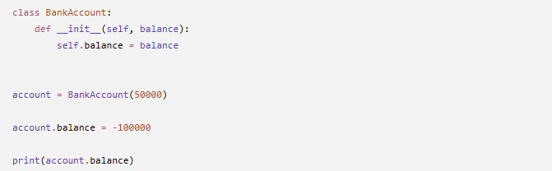
Without Encapsulation

Output: -100000
The program allowed an invalid balance.
This is a problem because the class has no control over how its data is modified.

With Encapsulation
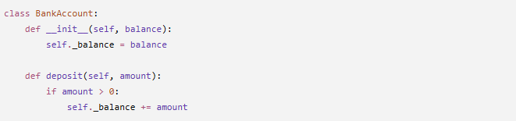
We can prevent invalid values:

Now the class controls how the balance changes.
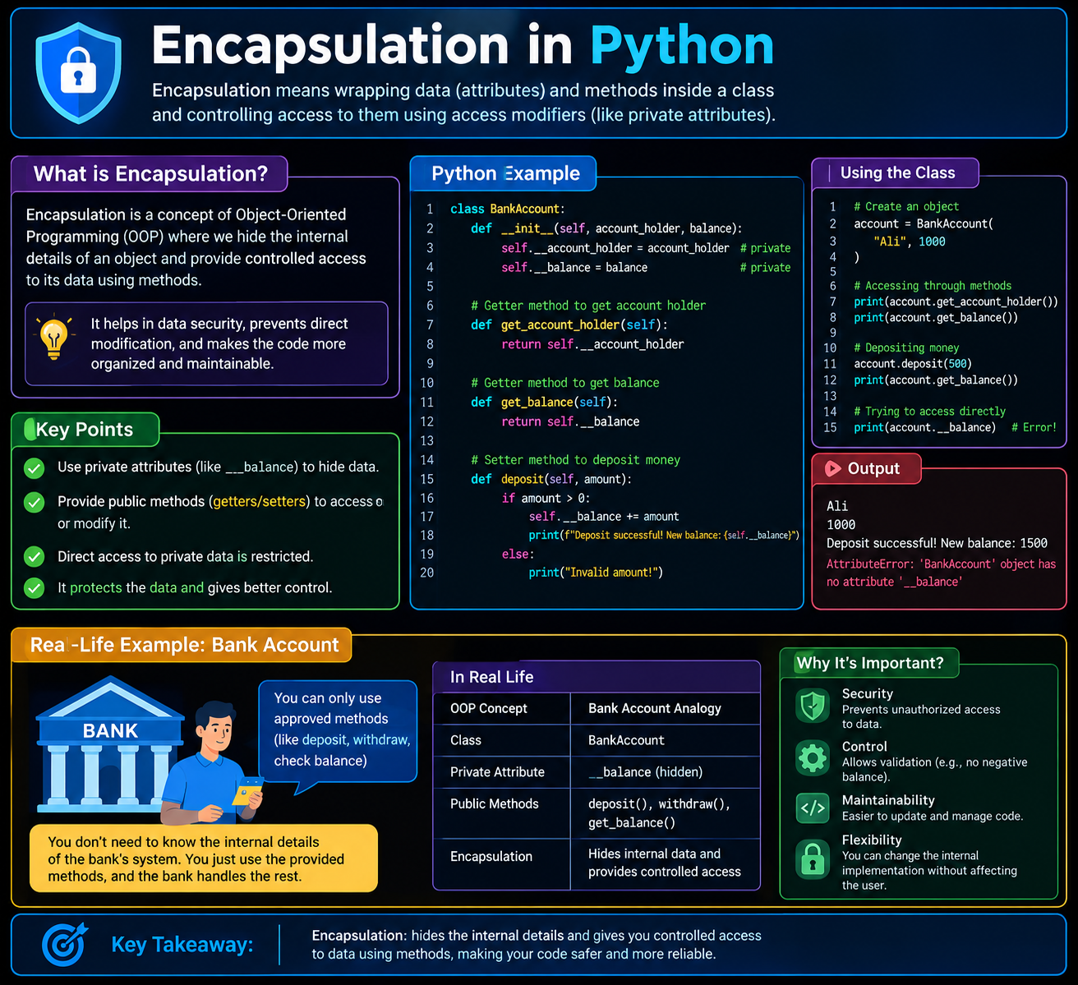

Access Control in Python
Python provides naming conventions for controlling access to class members.
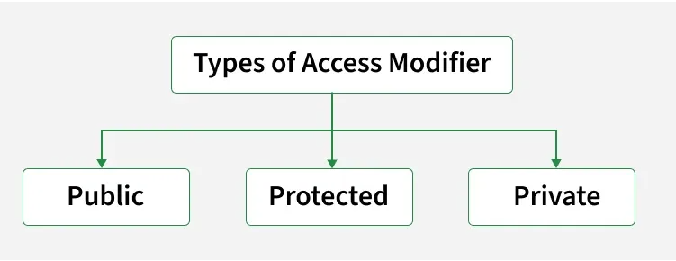
There are three commonly discussed access levels:

Access Level | Syntax | General Meaning
Public | name | Can be accessed normally from any class.
Protected | _name | Intended for class and subclasses
Private | __name | Intended to be accessible only inside the class

Public Members
A public member can be accessed from inside and outside the class.
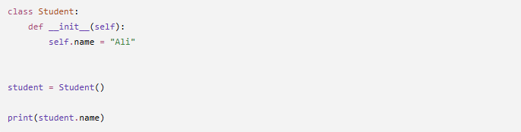
Example

Here, name is a public member.
It can be accessed directly: student.name

When should we use public members?
Public members are suitable when data does not require special protection or validation.
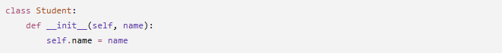
For example:

The student's name may be public.

Protected Members
A protected member is written using a single underscore (_).
Example:
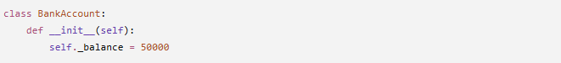

The _balance member is considered protected by convention.

It can still technically be accessed:

However, the underscore communicates:
"This attribute is intended for internal use and should not normally be accessed directly from outside the class."
Example:
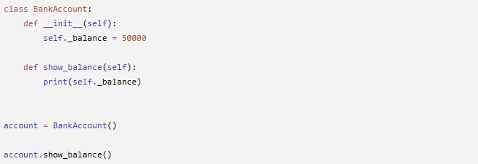

Python does not strictly prevent external access:

Private Members
A private member is commonly written using double underscores (__).
Example:
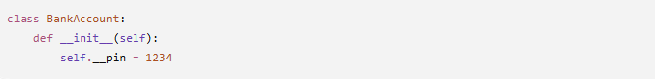

The PIN is intended to be private.
Trying to access it directly:
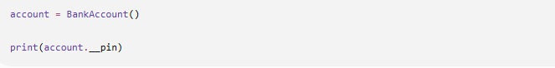

Will result in an error similar to: AttributeError
This helps prevent accidental direct access.
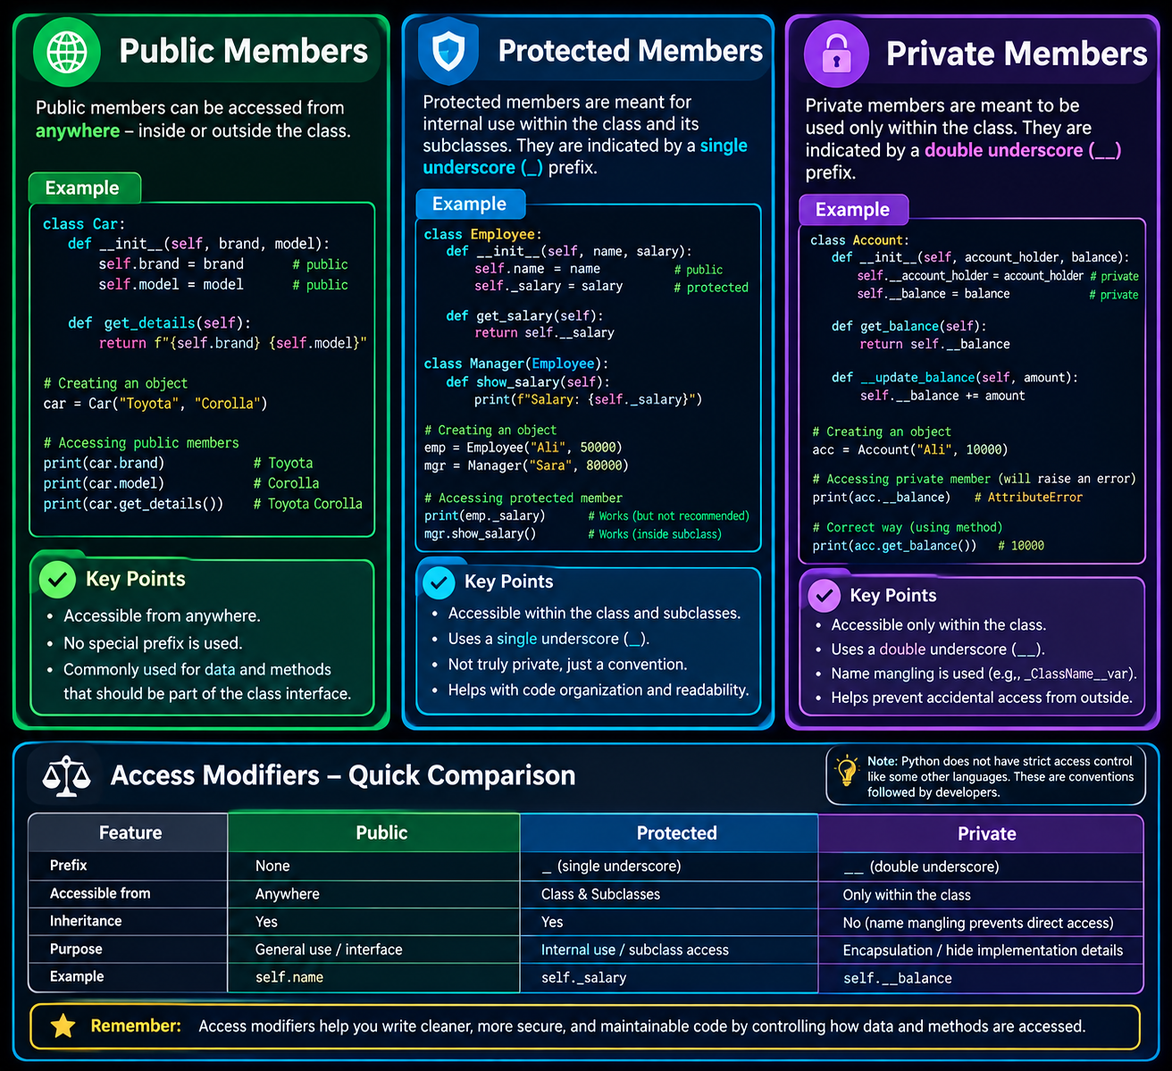

Name Mangling
Python implements private attributes using a mechanism called name mangling.
For example:

is internally transformed approximately into:
Therefore, the following may technically work:
However, this should not be used as a normal way of accessing private data.
The purpose of __pin is to indicate that the attribute is an internal implementation detail of the class.

Name mangling in Python is used to prevent naming conflicts in class inheritance, not to provide security. It is not a security threat because it is a transparent, predictable mechanism designed for code safety, not data protection.
Why Name Mangling is Used
- Prevents Overriding: It stops subclasses from accidentally overwriting internal base class methods or attributes.
- Avoids Name Clashes: It keeps identical variable names distinct when multiple classes in an inheritance chain use the same name.
- Signals Intent: It warns other developers that an attribute is intended for internal class use only.
Why It Is Not a Security Threat
- No False Security: Python documentation explicitly states mangling is not for data privacy or encryption.

Getter and Setter Methods
Another important technique for encapsulation is using getter and setter methods.

Getter
A getter is a method used to retrieve the value of an attribute.
Example:

Setter
A setter is a method used to modify the value of an attribute.
Example:

The setter allows us to validate the value before changing it.
Getter and Setter Example
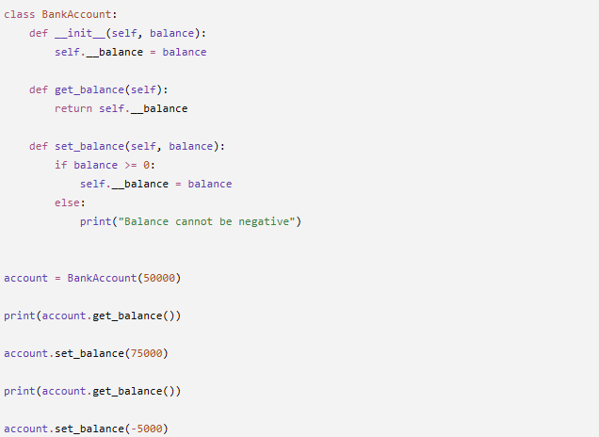

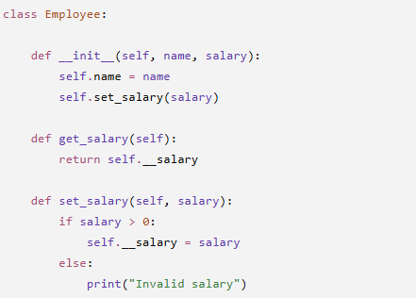
The important point is that the balance is not directly modified.
This provides controlled access.

Using @property
Python provides a cleaner way of implementing getters and setters using the @property decorator.
Instead of writing:
we can write:
while still keeping control over the attribute.
Basic @property Example
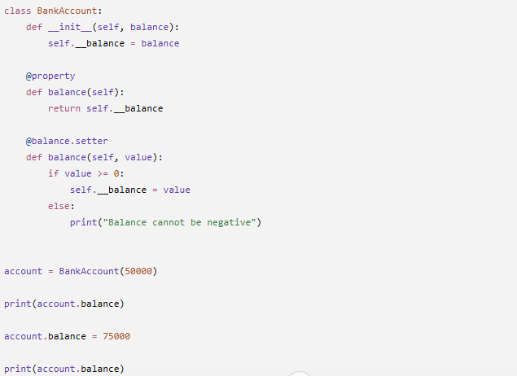

The syntax looks like normal attribute access:
But internally Python is calling the property getter.

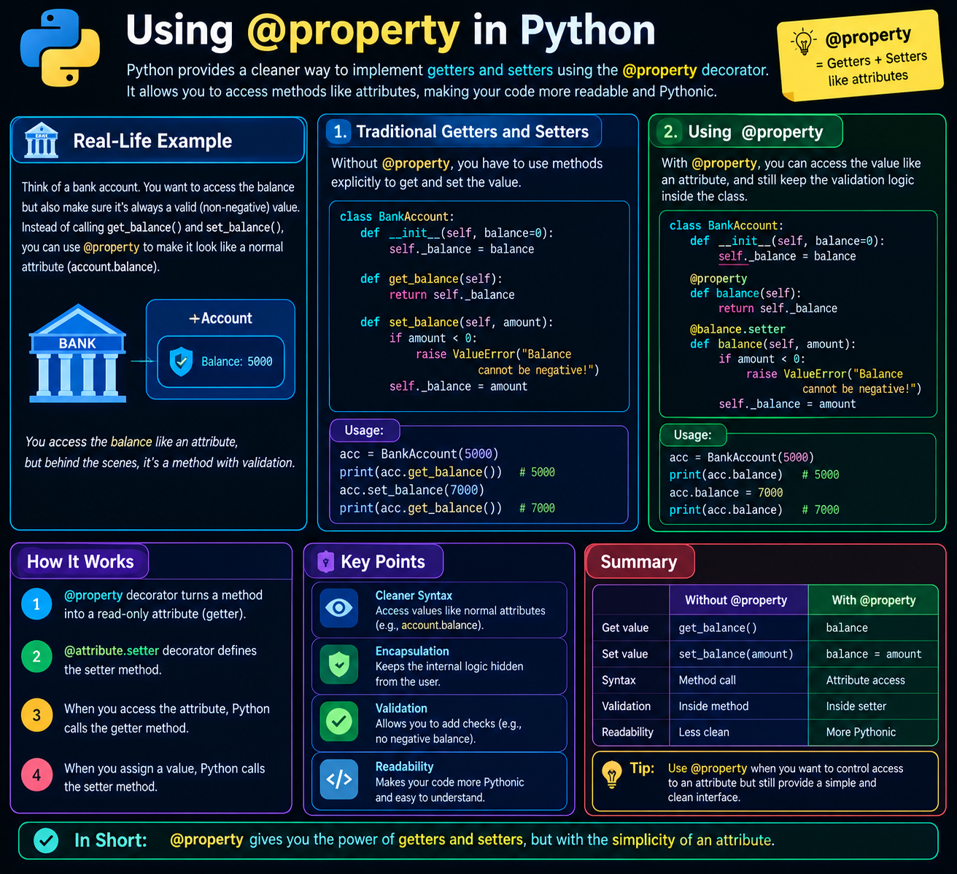

Practical Example: Bank Account
Now we will combine all the concepts into one practical example.
Our bank account will contain:
- Customer name → Public
- Account number → Protected
- Balance → Private
- PIN → Private
The class will provide controlled operations such as:
- Deposit money
- Withdraw money
- Check balance
- Change PIN
- Display customer information
Complete Code Example
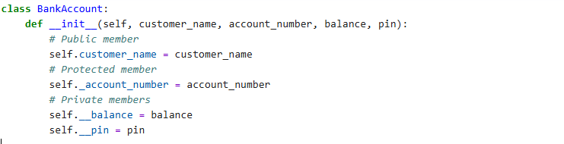
Step 1 Creating Class and Constructor

Step 2 Creating Getter and Setter Methods
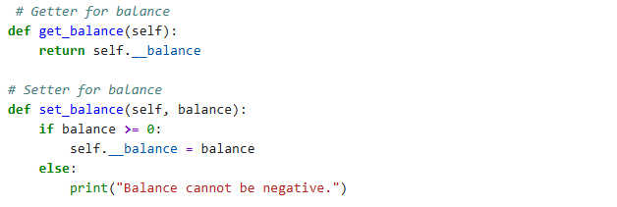

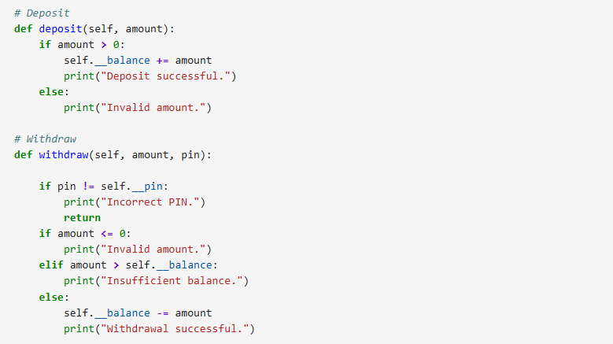
Step 3 Creating Deposit and Withdraw Methods

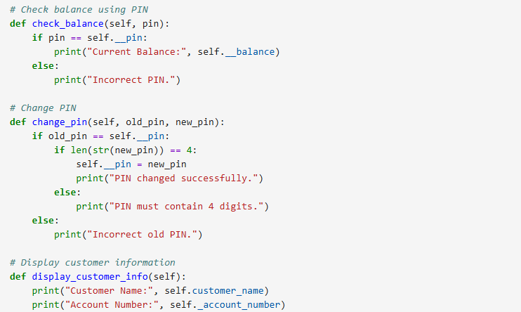
Step 4 Creating Check Balance and Change Pin & Display Methods

Step 5 Creating Object

Step 6 Accessing Public Data
The customer's name is public:
It can be accessed directly because it is a public member.

Step 7 Accessing Protected Data
The account number is protected:
This may work in Python, but it is not recommended as normal external access.
The single underscore communicates that the member is intended for internal/subclass use.
A better approach is to provide a method:

Step 8 Accessing Private Balance
The balance is private:
This will produce an error because __balance is name-mangled.
Instead, we use the getter:

Difference Between Getter/Setter and @property
Getter/Setter | @property
Uses methods such as get_balance() | Uses attribute-like syntax
account.get_balance() | account.balance
account.set_balance(50000) | account.balance = 50000
More explicit | Cleaner and more Pythonic
Common in many OOP languages | Common Python approach

Final Lab Task
Lab Task 1: Hospital Patient Management System
Create a Python class named Patient to develop a simple Hospital Patient Management System demonstrating encapsulation and access control.
Requirements
- Create the following class members:
  - patient_name as a public member.
  - _patient_id as a protected member.
  - __medical_history as a private member.
  - __emergency_contact as a private member.
- Implement getter and setter methods for __medical_history:
  - get_medical_history()
  - set_medical_history()
  - Ensure that the medical history cannot be set to an empty value.
- Use the @property decorator to provide controlled access to __emergency_contact.
- Create methods to:
  - Display basic patient information.
  - Update medical history.
  - Update emergency contact information.
  - Display protected patient ID information.
- The program should demonstrate:
  - Direct access to public information.
  - Appropriate use of protected information.
  - Controlled access to private information.
  - Getter and setter methods.
  - @property and @property.setter.
  - Validation of incorrect input.
- Create at least one patient object and perform different operations to demonstrate how encapsulation protects sensitive patient information.
Lab Task 2: Online Shopping Product Management System
Create a Python class named Product to develop a simple Online Shopping Product Management System demonstrating encapsulation and access control.
Requirements
- Create the following class members:
  - product_name as a public member.
  - _product_id as a protected member.
  - __price as a private member.
  - __stock as a private member.
- Implement getter and setter methods for __price:
  - get_price()
  - set_price()
  - The price must not be negative or zero.
- Use the @property decorator to provide controlled access to __stock.
- Create methods to:
  - Display product information.
  - Add stock.
  - Remove stock when a product is purchased.
  - Update product price.
  - Check available stock.
- Apply appropriate validation:
  - Product price must be greater than zero.
  - Stock cannot be negative.
  - Purchased quantity must be greater than zero.
  - A customer cannot purchase more items than the available stock.
- The program should demonstrate:
  - Public member access.
  - Protected member usage.
  - Private member protection.
  - Getter and setter methods.
  - @property and @property.setter.
  - Data validation and controlled modification.
- Create at least one product object and perform multiple operations to demonstrate how encapsulation protects product pricing and inventory information.

